Method Two (When Bill of Exchange is rejected by Bank because of LR of transporters not authorised)

Step 1: Bill of exchange payment Customer – F-36

Refer 02- FI-AR- 06 for Bill of Exchange Payment

Step 2: As under

S.NO. : 02- FI-AR- 09

TRANSACTION CODE : F – 30

ACCESS PATH :SAP Easy Access Accounting Financial
Accounting Accounts Receivable Document Entry
Other Int. Transfer Posting With Clearing

We get “ Post with Clearing- Header data” screen ;

Required Fields:

Document date : To be entered
Account : To be entered (Customer A/c Number)
Posting date : Default
Transaction to be
Processed : Incoming Payment

Rest all other fields viz, Doc Type, Period, Companycode,Currency/Rate are default after they are entered for the first time.

We get the Screen “Post with Clearing - Header Data“ incorporating the above
mentioned required fields as under;

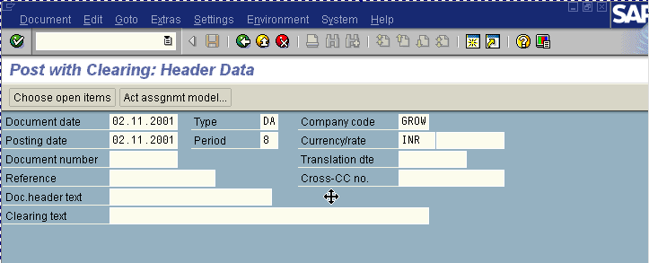
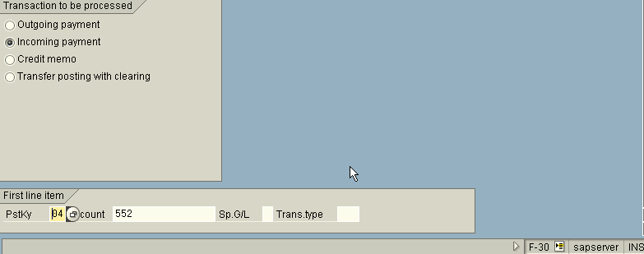

Press Enter Button

We get “ Post with Clearing – Add Customer Item” Screen

In the above screen enter the text field

Press enter button

The screen will display a message and will appear as under

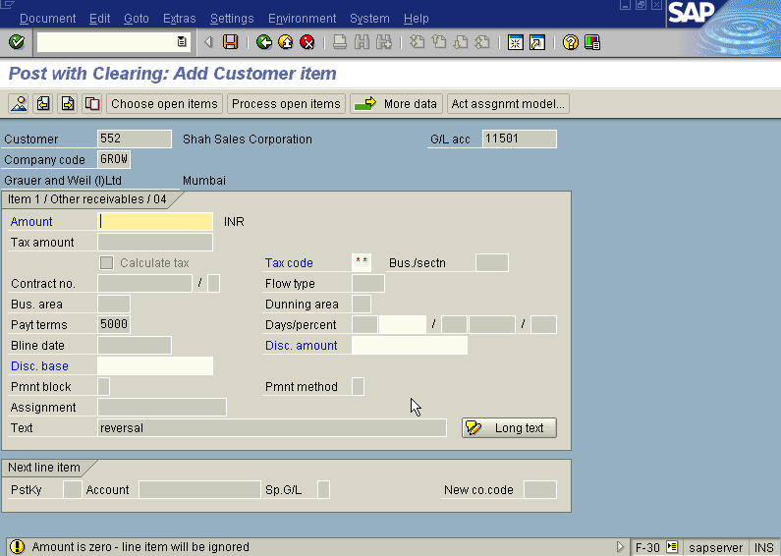

In the above screen fill the bline date field and press enter the system will fill the disc. Base and then press Process open item button

We get “Post with clearing – Select open item” Screen as under

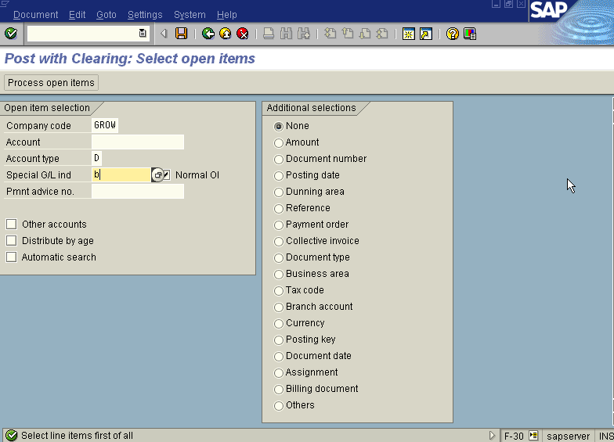

In the above screen fill the account & Spl. G/L ind. Fields and

Press Enter button

We get “ Post with Clearing – Process Open Item” screen as under
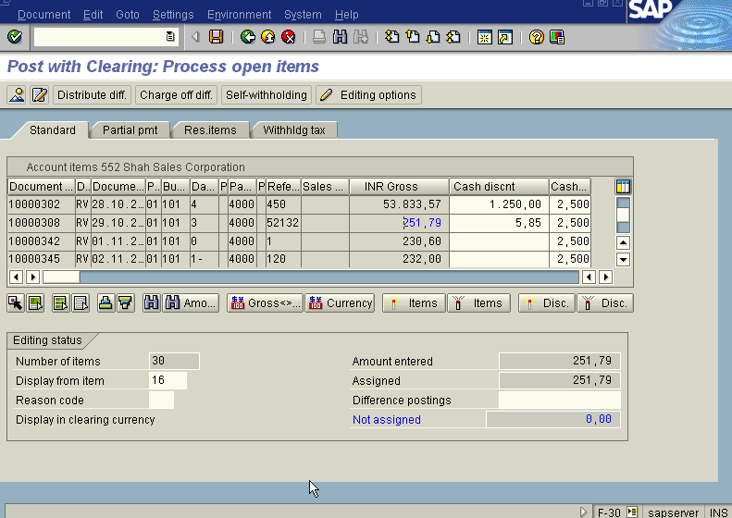

In the above screen first press icon select all so that all the items get selected and turns blue. Then press icon Deactivate so that all items in blue turns black. Now select the invoice document so as to make the as make the above screen will display in the not assigned portion the discount amount.

Press Save button

The system will display the message as under

Take the note of the above number 1600092.

From this screen itself, you can see the document by choosing Document Display. The Document overview screen will be displayed as under showing the entries.
